**Docker Task -2**

**Task Description:** Create a dockerfile, docker-compose file which when executed must display your basic details in the website.

Step 1: Launch an AWS Ubuntu EC2 Instance

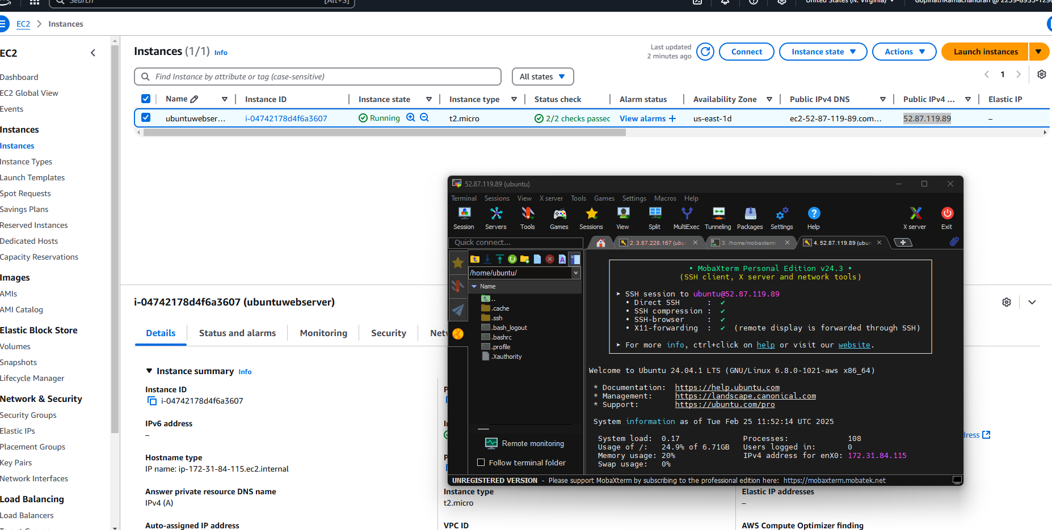

Step 2: Install Docker & Docker Compose

Start and enable it then create user and execution permission

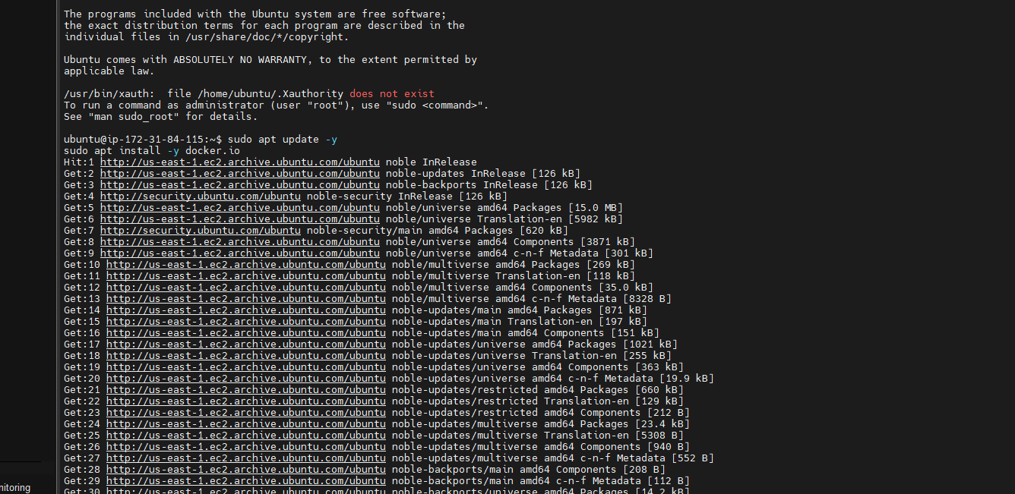

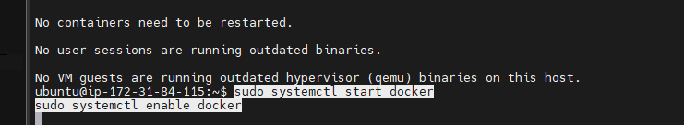

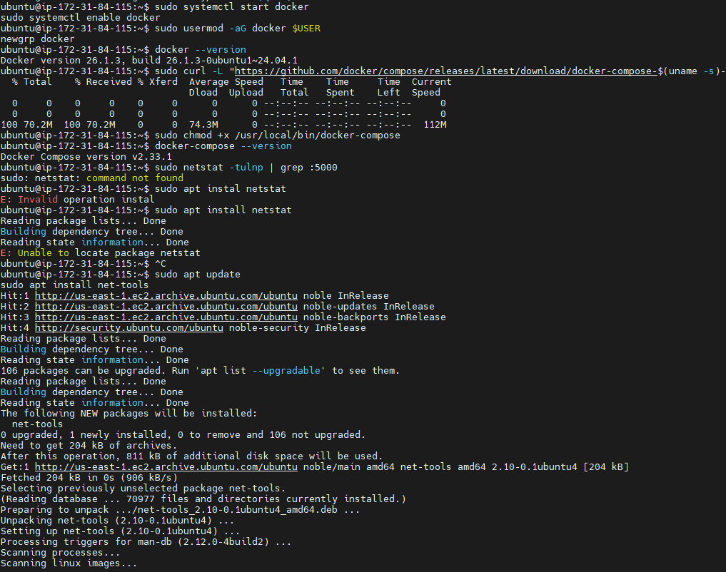

Step 3: Create the Project Directory

Step 4: Create the Required Files

1. Dockerfile
2. docker-compose.yml
3. requirements.txt
4. Flask application (app.py)
5. HTML file (templates/index.html)

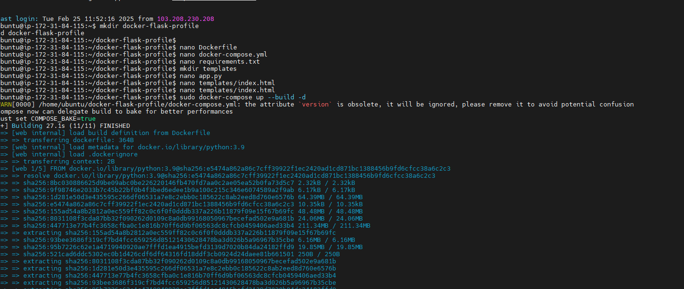

Step 6 : Build and Run the Docker Container

Step 7: Allow Traffic on Port 5000

Step 8: Access the Website

